Selenium to Playwright converter

Below are the issues I faced while implementing this flow
Issue 1 – Call between 1st and 2nd workflow didn’t work at first. This issue got resolved only when I published the 2nd node and then trigger the entire workflow

Issue 2 – In the sub-workflow, it was generating and sending only the final test cases file instead of all test case files. This issue got resolved only when I removed the Code in Javascript node in Sub-workflow. Flow is Working fine even without the code in javascript node in the sub-workflow

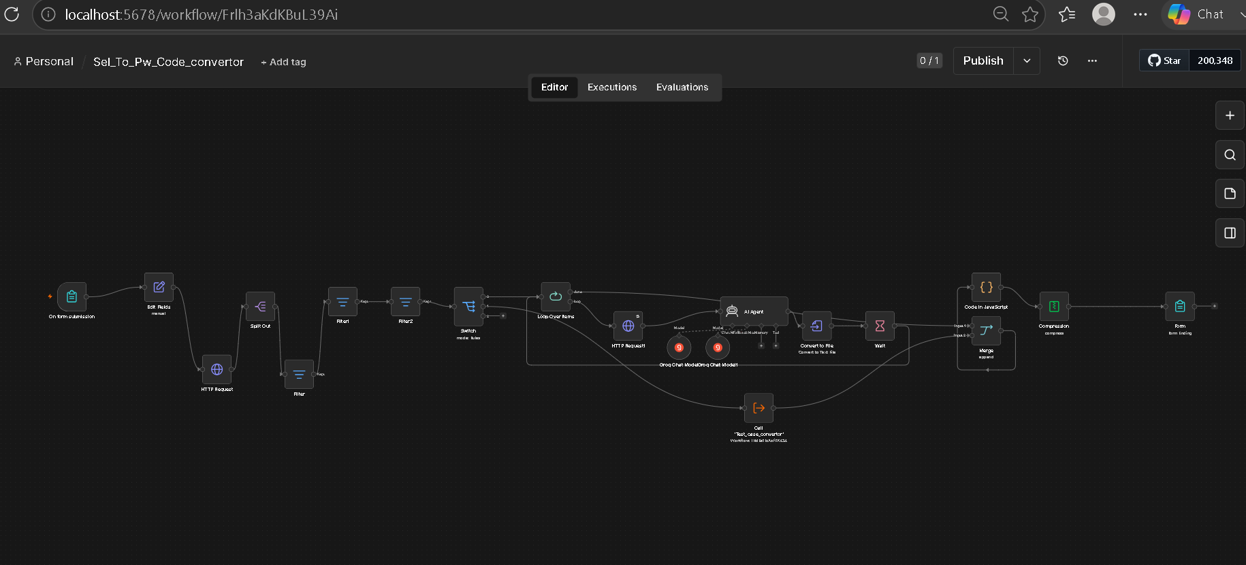
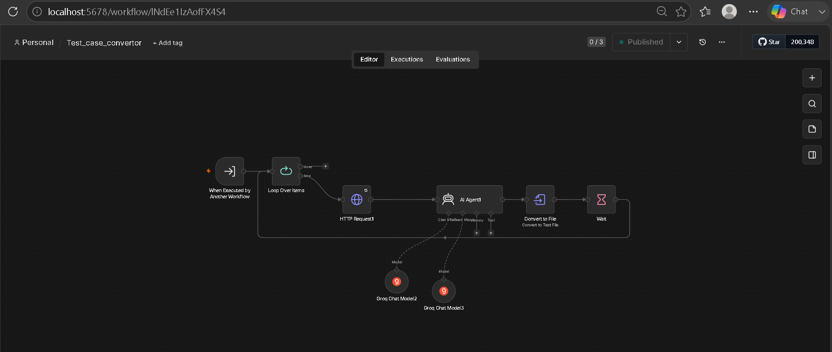

Files which are generated
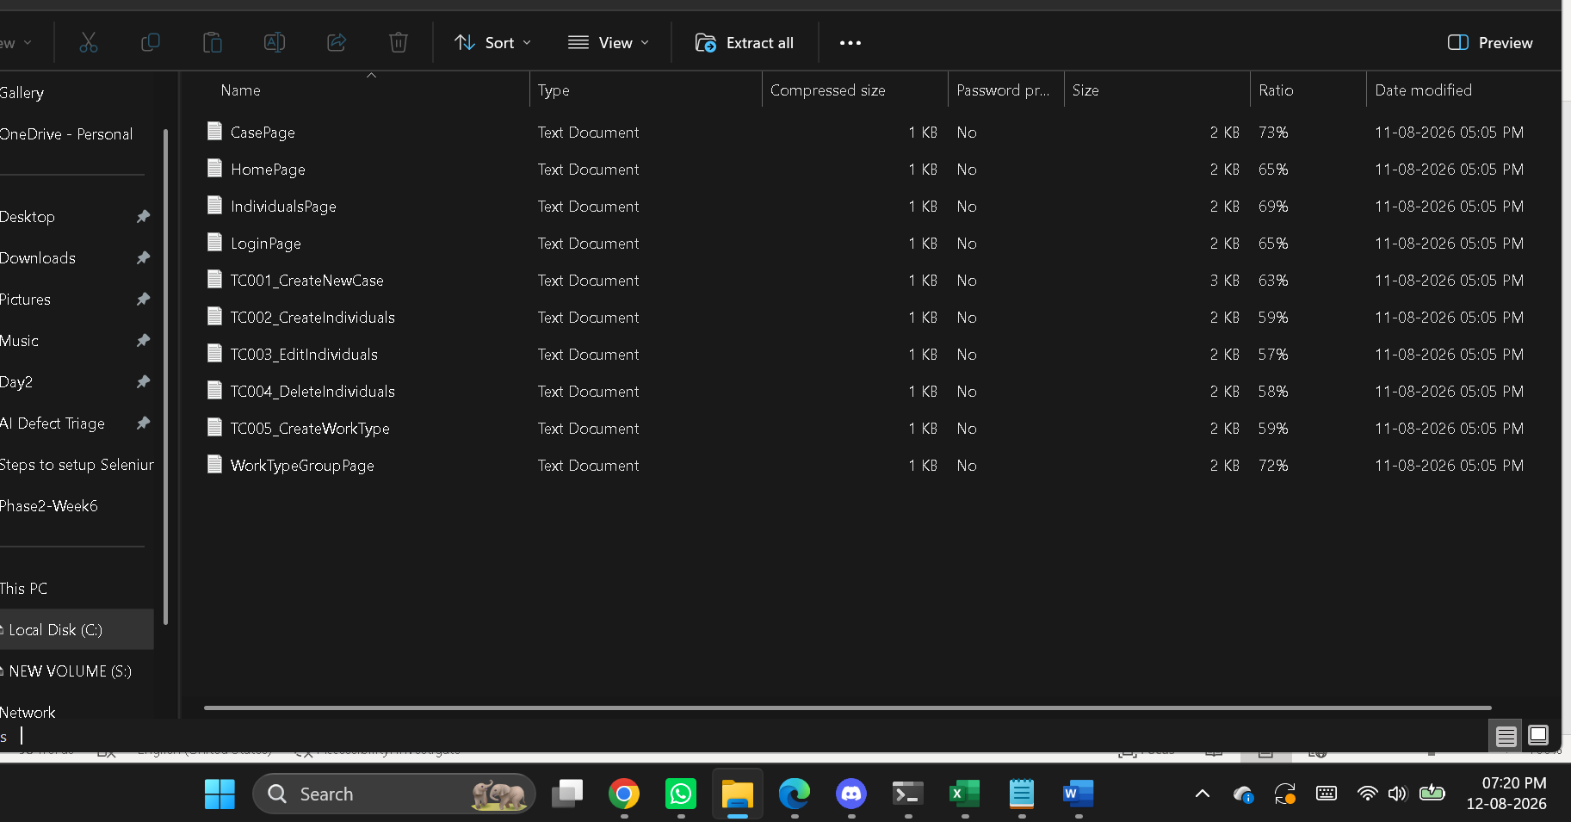

Sample Playwright output generated:
